**Performed steps**

1. Open the calculation simulation.
2. Set all properties setting values.
3. Input 6 numeric boat speeds and record the output.
4. Compare the simulation results with real data.

**Results**

This are the results with the simulation:

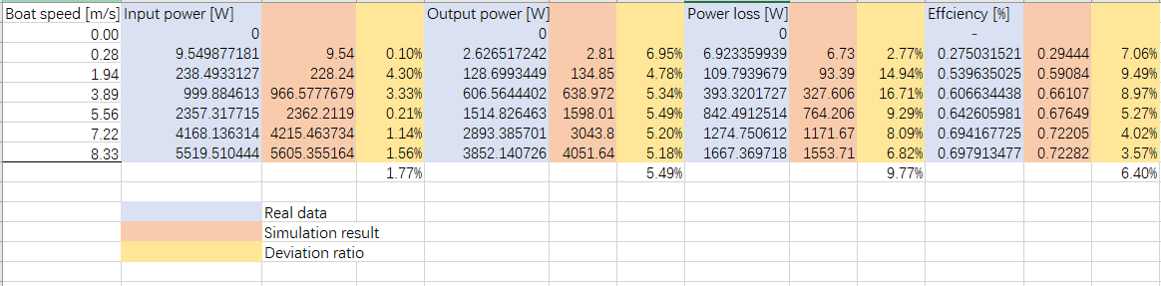

This picture shows the simulation results. Blue blocks contain real data, red block simulation results and yellow blocks contain deviation ratio. The deviation ratios of four outputs are all lower than 10%.

**Conclusion**

The results of this test are same to the desired result, with different inputs, there will be different correct corresponding input power, output power, power loss and efficiency. And all results have deviations less than 10%.